Week 9 - Activity 1
Project Title: Pet Adoption and Shelter Management System
Group Name: Group N
Team Members: Ravindu, Sandali

Waterfall Project Management Diagram
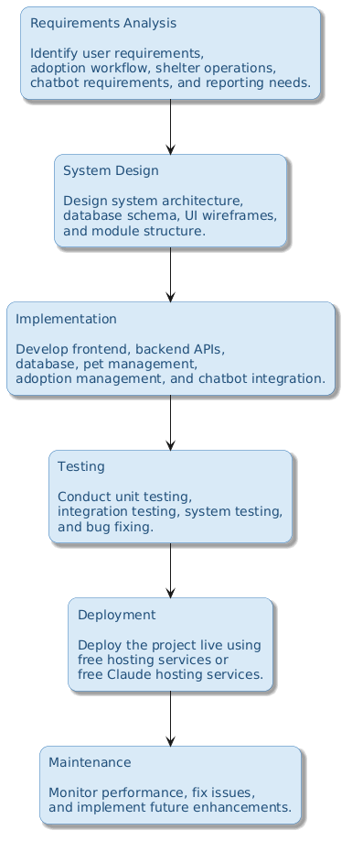

Project Schedule
Phase | Description | Timeline
Requirements Analysis | Identify user requirements, adoption workflow, shelter operations, chatbot requirements, and reporting needs. | Week 1
System Design | Design system architecture, database schema, UI wireframes, and module structure. | Week 2
Development / Implementation | Develop frontend, backend APIs, database, pet management, adoption management, and chatbot integration. | Weeks 3–5
Testing | Conduct unit testing, integration testing, system testing, and bug fixing. | Week 6
Deployment | Deploy the project live using free hosting services or free Claude hosting services | Week 7
Maintenance | Monitor performance, fix issues, and implement future enhancements. | Ongoing

